**Canadian Institute of Technology**

Faculty of Engineering   
Software Engineering Department

**To-Do Application**

*A project submitted*

*in partial fulfillment of the requirements for the degree of*

*Bachelor Studies in* Software Engineering

**by**

Arteo Fejzo, Fabjo Ago

**ABSTRACT**

It’s hard to keep up with our daily routines and tasks and of course sometimes we need help remembering what to do and when to do it. This java application fixes that by registering users and allowing to insert their tasks into the app, also it lets them add a due date to each task. You can delete tasks, send them to the trash, manage your user data and update them. The tasks are stored and they can be easily managed through a user-friendly GUI, simple and efficient. Instructions for using are inside the app, every frame has it’s own specifications and displays the correct messages so the user can understand how the data should be inputted and how the app can be used.

**SOFTWARE REQUIREMENTS**

Having a PostgreSQL database running on your machine and having Java installed in order to run the .jar file. (The PostgreSQL database code is also provided inside the zip). The user for the database is “postgres” and the password is “arteofejzo”, port “5432”.

**SCREENSHOTS**

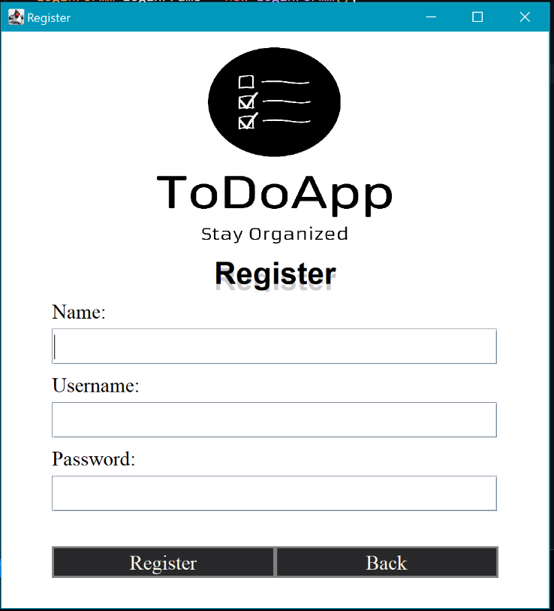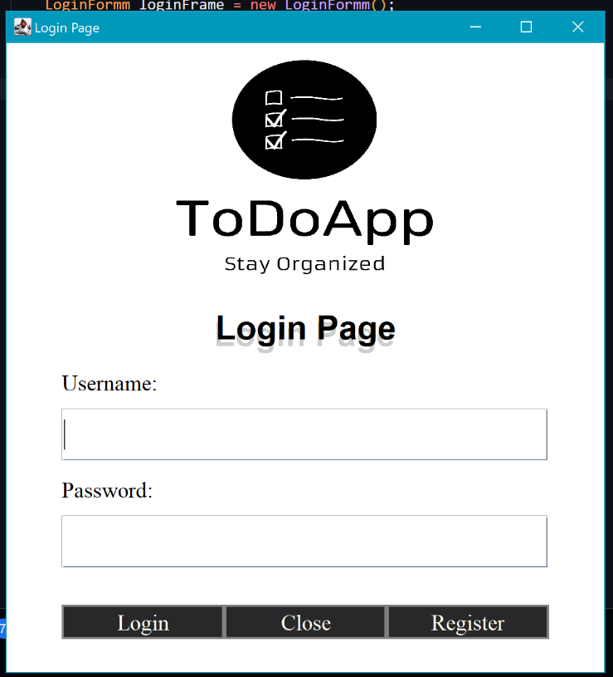

Figure 2: Register Frame

Figure 1: Login Frame

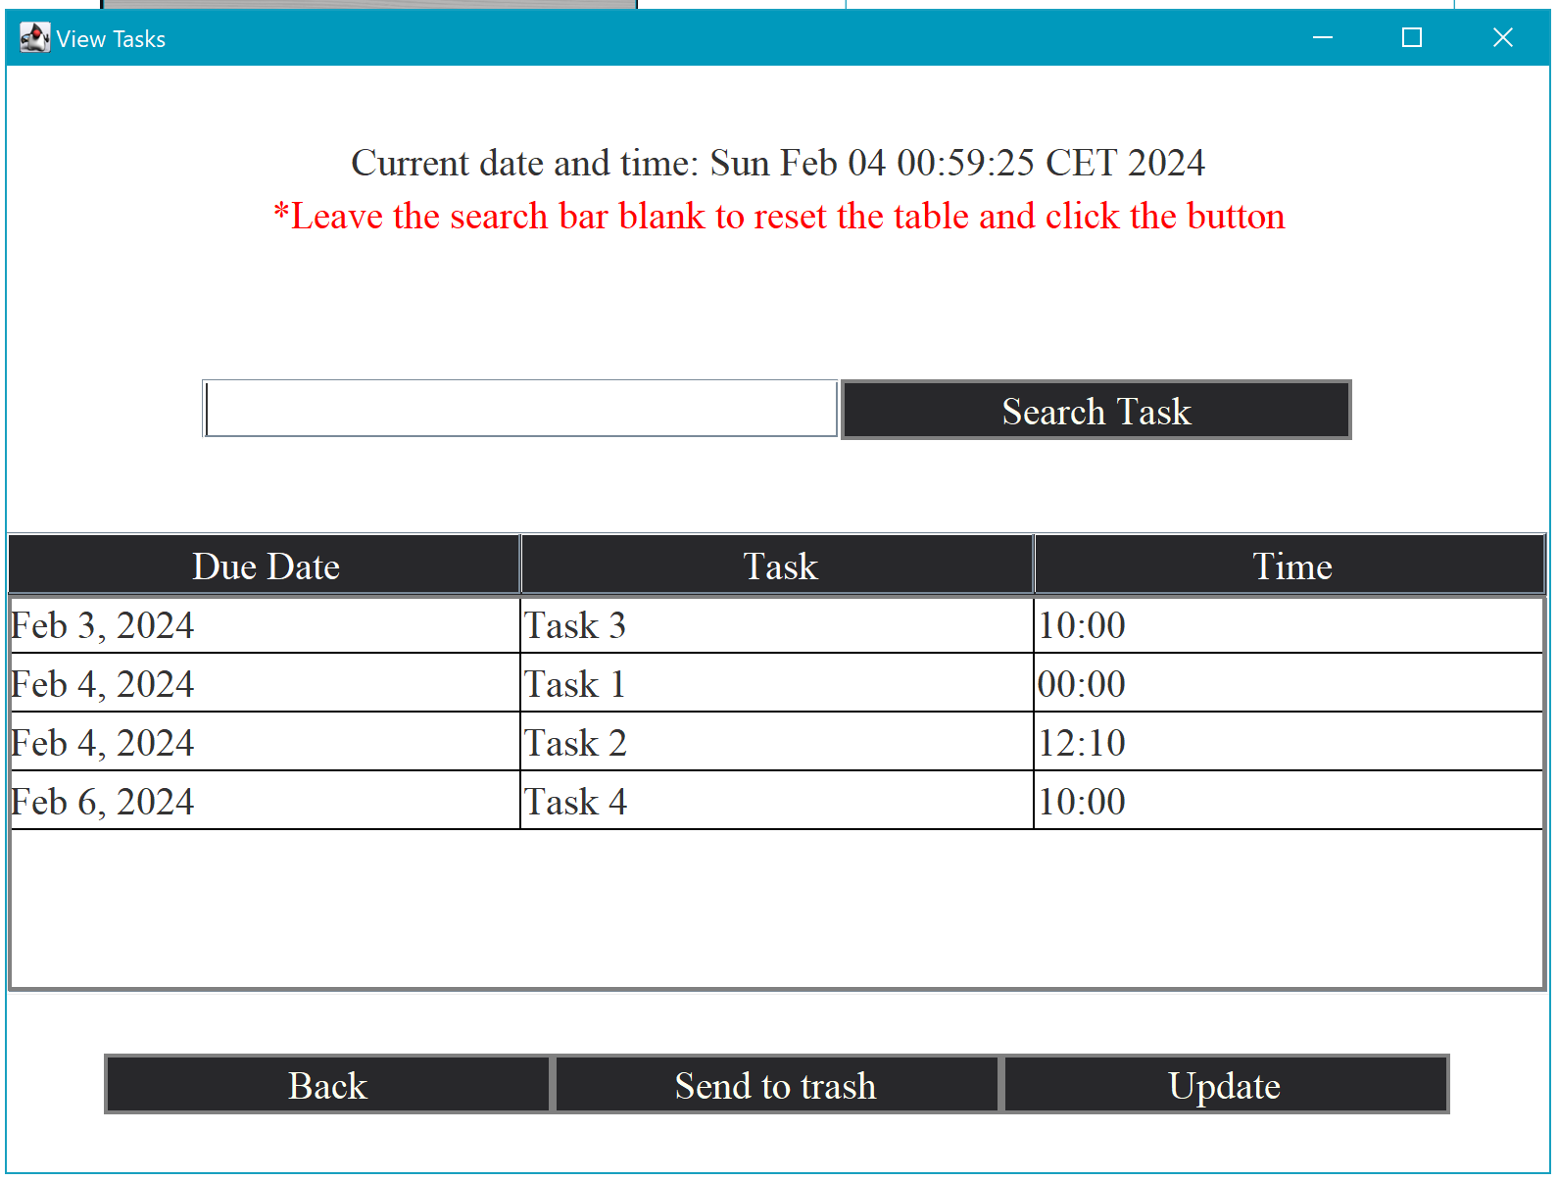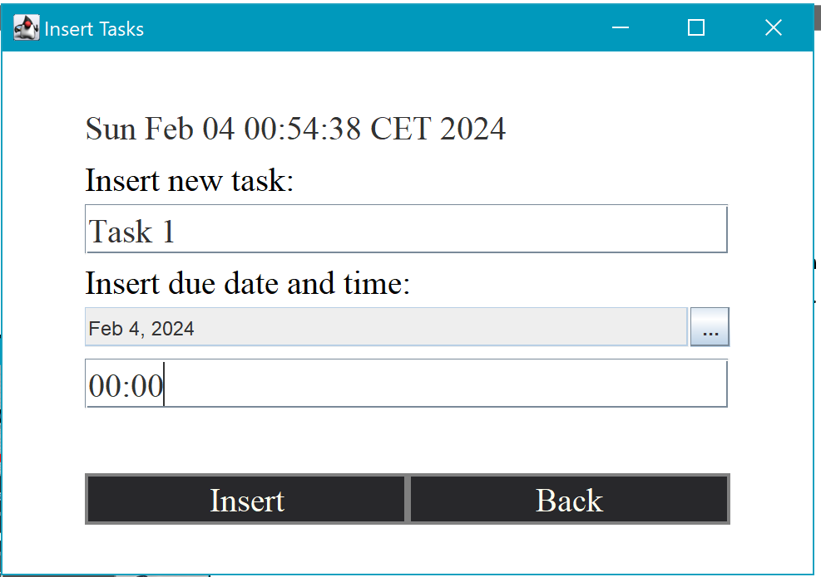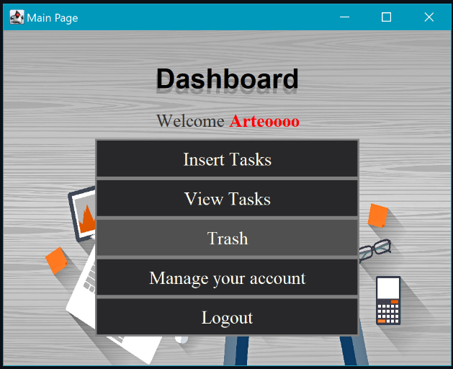

Figure 4: Insert Task, It will show a message if the inserted time is not in the correct format hh:mm. (24h format).

Figure 4: View Tasks, here the user can search for a task, send a task to trash and update a task, as you can see each task is ordered by the closest due date and time.

Figure 3: Main Frame

Figure 6: Manage User, here you can update your user details or permanently delete your account

Figure 5: Trash, you can permanently delete tasks here or also restore them

# 

# 

# 

Figure 7: Users table

Figure 7: Tasks table

# 

# 

Figure 8: Trash table

**Challenges**

One of the things we did not do was the searching and sorting algorithms. Since we fetched the data from the database and used the ORDER BY keyword in the query, we got the tasks already sorted, same goes for searching in which we used the LIKE keyword.

# *Background Information*

The title of this project is To-Do Application. It is to make managing tasks that a person has to do easier. The user can register and log in on the app and assign tasks along with deadlines. With this application the user can easily keep track of the tasks that he/she has to do. We used javax.swing library to develop the GUI. We made the GUI with coding and not with NetBeans IDE’s GUI interface. We also added an extra library called jdatepciker.jar. PostgreSQL connector J version was used to make the connection of the java project with the database

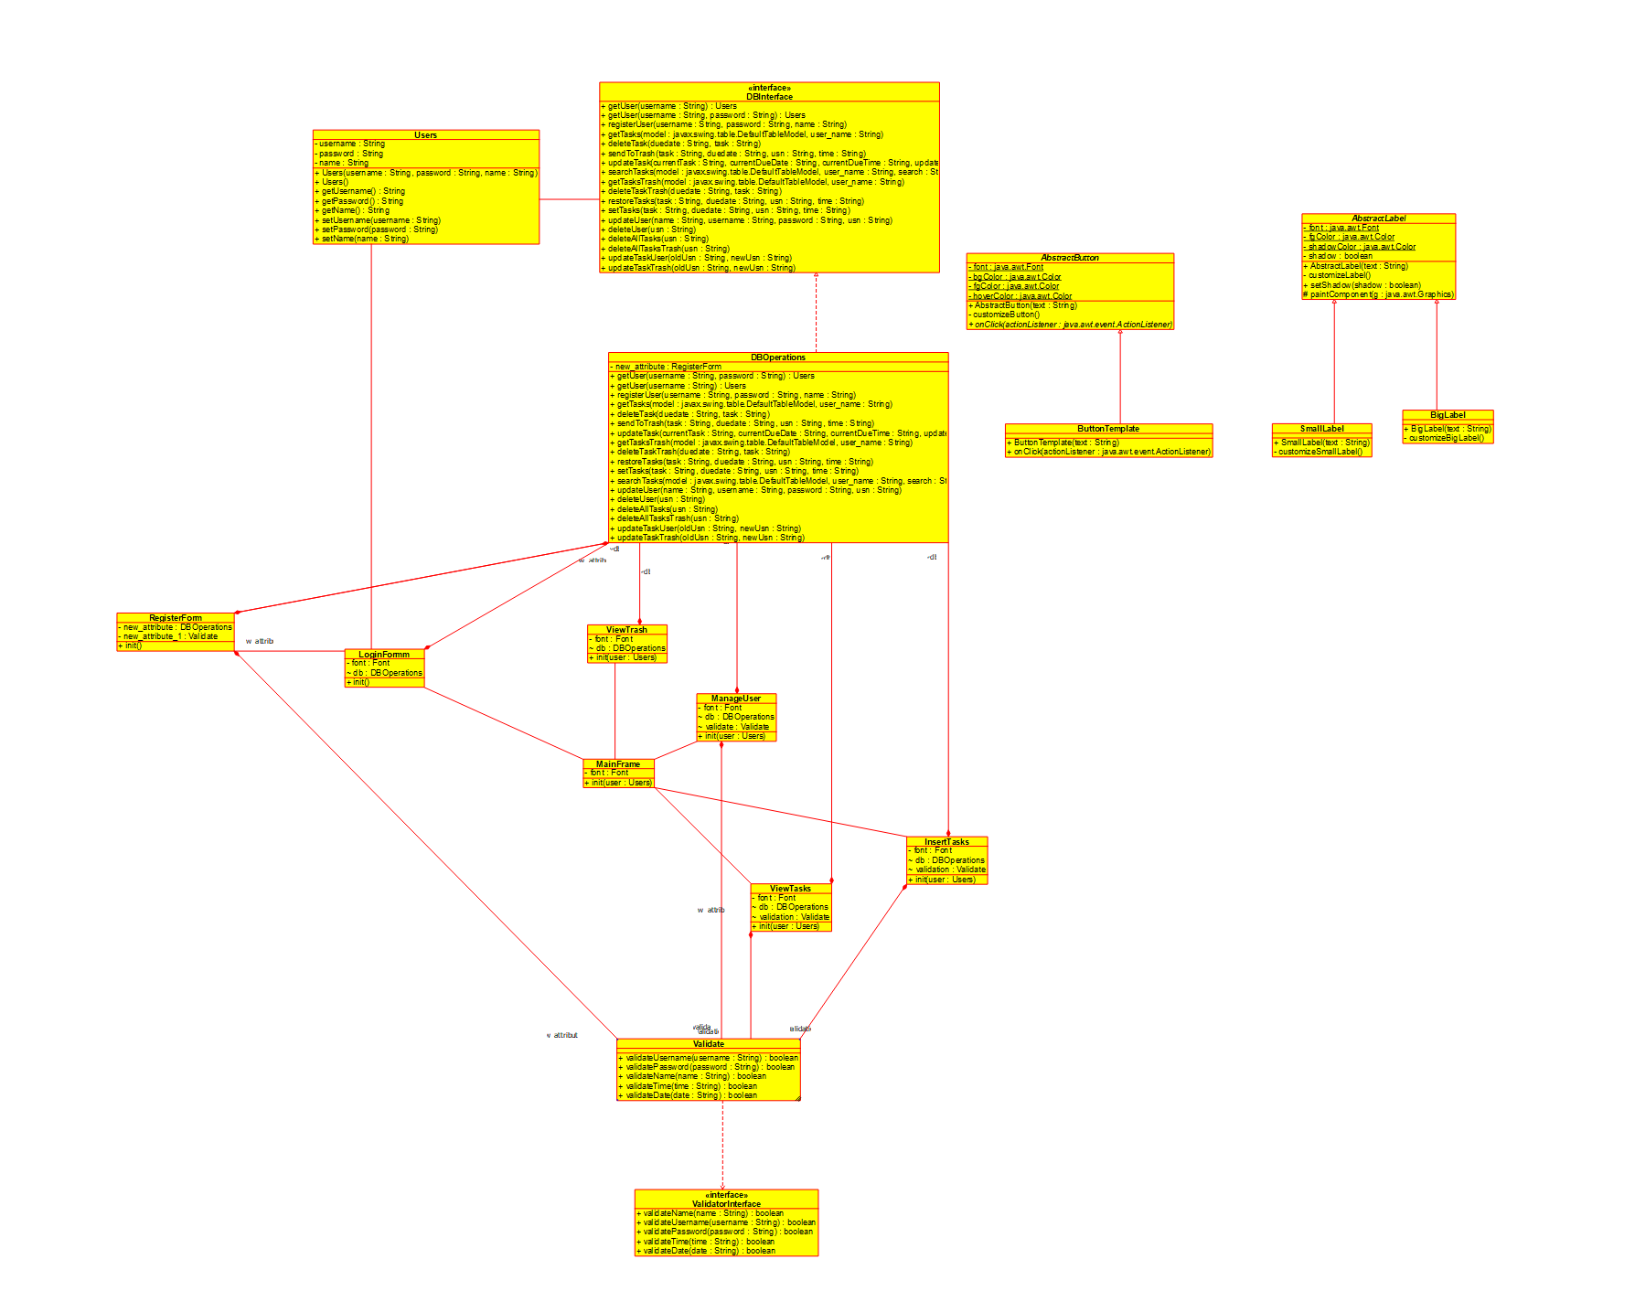UML DIAGRAM

Showing the relationship between the java classes as best as we could using an UML Class Diagram made with the app “umbrello”.

**Conclusion**

This To-Do Application fulfills its purpose to a certain extent and it can be easily used by everyone. Overall, the application has flexible functionality, users can add or delete tasks as needed, log in or register with their own credentials. The To-Do Application is a great tool for anyone looking to stay organized and on top of their tasks.

**REFERENCES**

<https://www.youtube.com/watch?v=5G2XM1nlX5Q> (With this youtube video we got the fundamentals of coding a GUI Java app in Visual Studio Code)

<https://www.youtube.com/watch?v=WFT5MaZN6g4> (With this video we learned how to use a PostgreSQL Database)